CLIENT GUIDE

SOMFIX Sales and Jobs Workflow
Purpose This guide explains how SOMFIX turns a public repair request into completed field work, a paid invoice and a closed job. Each record stays linked, so staff can see the customer history, costs, payments and next action from one workflow.
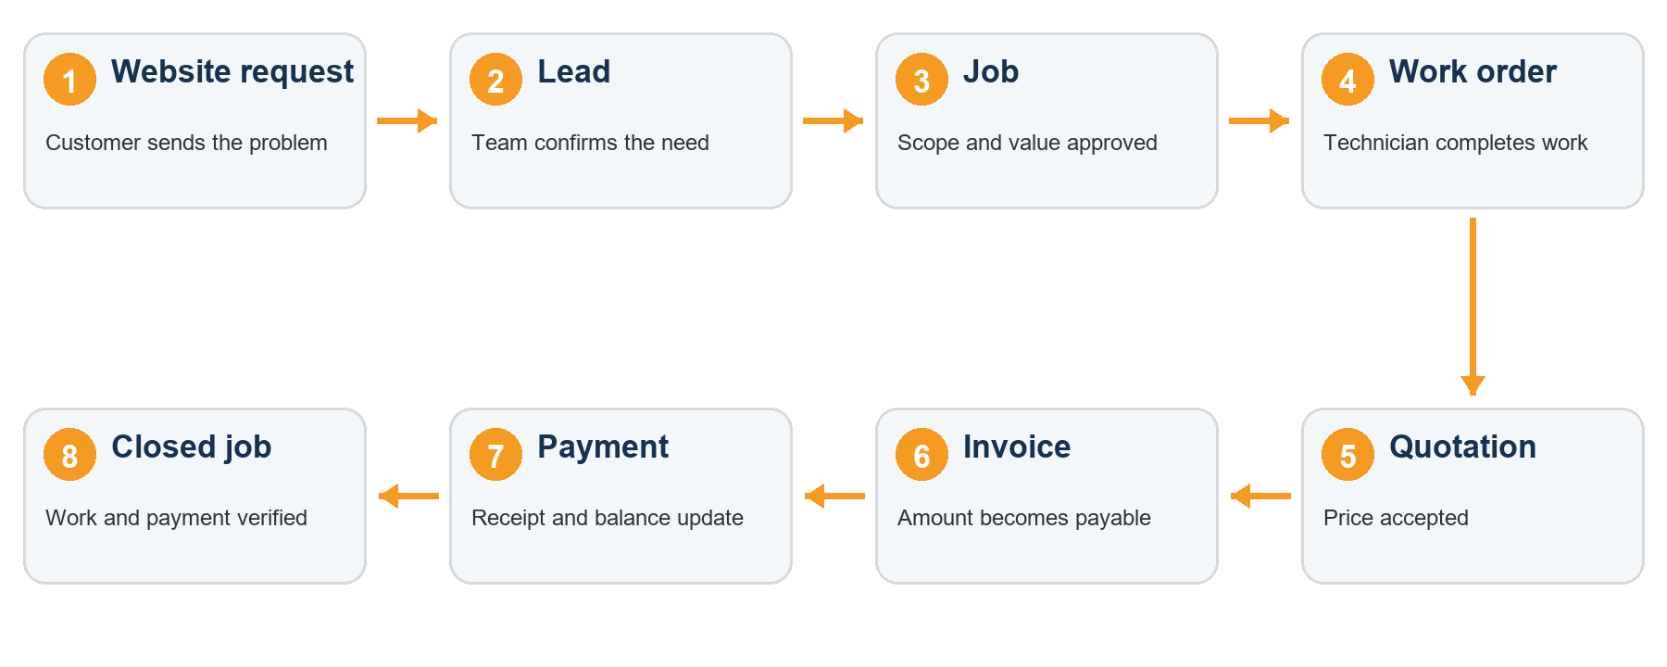

What the workflow controls
- Every website request can become one customer and one sales lead without retyping the contact information.
- The approved lead becomes a job that connects work orders, materials, labor, quotation, invoice and payments.
- A job closes only after the work is checked and the financial balance is understood.
Main result Operations and finance work from the same customer story instead of separate lists.

PAGES USED BY RECEPTION AND SALES

From website request to approved job
1 Receive the request The customer submits the public contact form with name, phone, area, service and a description. The request appears under Website Requests.
2 Contact the customer Call or WhatsApp the customer, confirm the problem, location, urgency and preferred visit time. Keep the original request as the source record.
3 Create the customer and lead Select Create customer and lead. SOMFIX reuses an existing customer with the same phone number or creates a new customer, then opens a website lead linked to the request.
4 Qualify the lead Update the service category, estimated value, property or unit, preferred visit date and lead stage. Use notes for access instructions and follow-up actions.
5 Create the job When the customer approves the work, select Create job. The job keeps the customer and lead link and becomes the main record for delivery and billing.

Who does what
Role | Main responsibility | Record updated
Reception | Review new requests and contact the customer | Website request
Sales | Qualify the need, agree scope and prepare price | Lead and quotation
Operations | Schedule and verify field work | Job and work order
Finance | Issue invoice, record payment and provide receipt | Invoice and payment

PAGES USED BY OPERATIONS AND FINANCE

From field work to payment
6 Create the work order Create a linked work order from the job, assign the technician, schedule the visit and update the work order from pending to completed.
7 Record actual delivery Add inventory items used and labor hours. Material entries reduce stock automatically. Labor and material costs feed the job profit view.
8 Prepare the quotation Create the quotation from the job. Include the agreed scope, line items, amount, customer name and validity or due date. Mark it sent, accepted, rejected or revised as appropriate.
9 Convert to invoice After acceptance, convert the quotation. SOMFIX preserves the quotation and creates a linked invoice with its own number and outstanding balance.
10 Record payment and close Record cash, EVC Plus, bank transfer or another method. The invoice becomes partially paid or paid from its balance. Print the receipt, confirm the repair, then close the job.

EVC Plus payment shown on documents
Payment item | Customer instruction
Merchant number | 65 21 09
USSD code | *789*652109*$#
Reference | Record the transaction reference with the payment

DAILY OPERATING REFERENCE

Statuses and completion checks
Record | Normal status path | Ready to move on when
Website request | New to Converted | Customer and lead links exist
Lead | New to Contacted to Inspection scheduled to Quoted to Converted | Scope and customer approval are recorded
Job | Approved to Scheduled to In progress to Awaiting verification to Completed to Invoiced to Closed | Field work and financial follow-up are complete
Work order | Pending to Assigned to In progress to Completed | Technician, dates, hours and notes are recorded
Quotation | Draft to Sent to Accepted | Customer accepts the amount and scope
Invoice | Sent to Partially paid to Paid | Balance reaches zero or an approved balance action exists

End of job checklist
- The website request, customer, lead and job open from each other.
- The work order shows the assigned technician, dates, status and completion notes.
- Materials and labor match the work completed on site.
- The accepted quotation and invoice are linked to the job.
- Every payment has a method, date, reference and printable receipt.
- The customer confirms the repair before the job is marked closed.
Support rule If a record cannot move forward, check the previous linked record first. The workflow is designed so each stage supplies the information required by the next stage.

